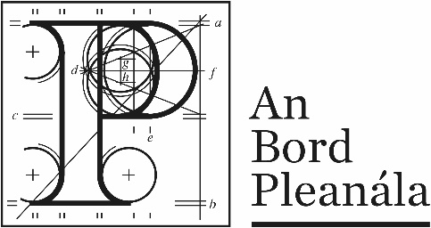
Documents received at Oral Hearing for
ABP-314232-22

Case Description | DART+ West Railway Order - Dublin City to Maynooth and M3 Parkway County Dublin, County Meath, County Kildare
Date | 4th October, 2023
Location | 64 Marlborough Street, Dublin 1, D01 V902

Documents received at Oral Hearing
No. | Submitted by | Presenter | Topic
 | Applicant | Mark Kilcullen | Module C  1.Slides Ashtown LX replacement  2.Railway_Safety_Performance_Report_2020  3.Network Rail Enhancing-Level-Crossing-Safety-2019-2029
 | o’mahony pike | Ms Susan Dawson | Module C  Castlethorn Construction
 | Applicant | Barry Corrigan | Module C  Ashtown photomontages
 | Applicant | Barry Corrigan | Module C  1.Preferred Option Percent  2.RSA report for Section A_ Spencer Dock  3. DEPOT ARCHITECTURAL -BUILDINGS Drawings
 | Pat Allison | Pat Allison | Module C – Ashtown  1.Wetlands along Canal West of Longford Bridge Images  2. Breakdown of incidents  3. Whitethorn Hedges Both Sides Ashtown Road Images  4. 1 page of writing (Navan Road Community Council)  5.Drawing – Station Design
 | Transport Insights – Transport Planning Consultants | Eoin Munn | Module C – Musgrave Operating Partners Ireland Limited

